**FLOWCHART POCKET EYECARE**

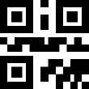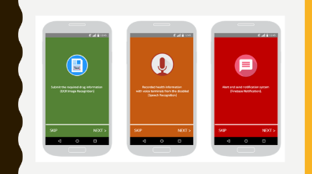Image result for facebook logo

SUPPORT

Pocket Card ORDER

STORE

YES

NO

YES

YES

NO

Sign In

USER AUTH

NO

Success

STORE

Success

Payment

MENU

FAVORITE

OCR Image

Offers

NOTIFICATION

QR CODE

Success

SETTING

END PROCESS